Ministers Prayer Meeting — Monday — 10:15–11:30 a.m.
Mar. 14 — Pastors/Ministers meet for fellowship and prayer.
Mar. 21 — Pastors/Ministers meet for fellowship and prayer.
“²¹The people said to Joshua, ‘No, but we will serve the LORD.’ ²²Joshua said to the people, ‘You are witnesses against yourselves that you have chosen for yourselves the LORD, to serve Him.’ And they said, ‘We are witnesses.’”
Joshua 24:21-22 (NASB)
______________
http://morganassociation
.weebly.com/

https://www.facebook.com/morgancountyalabama/
(256) 773-5243
______________

MBA News and Notes Volume 7, Issue 9, March 9, 2022

  - 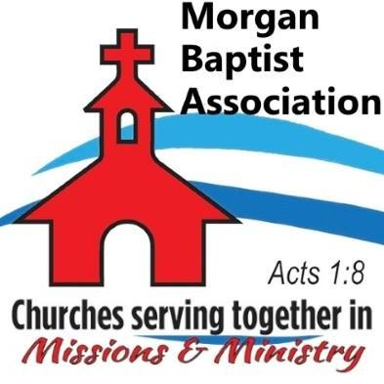

  - Volume 1 | Issue 43
October 26, 2016
Sharing Hope Conference — March 13, 5:30 pm. evening service and March 14, 11:30 am. An annual statewide event for encouraging and equipping pastors and churches in the work of evangelism. — First Baptist Church, Cullman.
BCM (Baptist Campus Ministries) Bible Study — Calhoun Community College Campus ⎯ March 15, 12:00 Noon ⎯ Campus Bible study for students at CCC. Instructor: Will Faulkenberry.
Ministry Training Institute (MTI) — March 15, 6:00-9:00 pm. MTI will continue a study of the Parables of Jesus. Instructor: Matt Haines.
Pastor Enrichment Network (P.E.N.) — March 15, 6:30 pm — MBA Office —Bivocational Ministers and Wives will meet for fellowship and Bible study.
Cross Planning Meeting — March 16, 11:00 am — Nature’s Trail Church, Decatur — Meeting to discuss installing a cross on Highway 67.
Pastors’/Friends’ Golf Outing — March 17 — Gunter’s Landing, Guntersville. Call (256) 466-1854 to reserve your spot. Meet at MBA at 7:00 am.
MBA VBS Teacher’s Clinic — April 4, 5:30-8:30 pm. — Training for associational VBS teams and teachers. — New Center Baptist Church, Hartselle.
MBA Disaster Relief Team Meeting — April 5, 10:00 am — Hacker Hall.
Transitional Pastor Training — April 11-12 — Training for pastors to help them strategically lead churches during the transitional period as they seek a new pastor. Cost: $25. ALSBOM home office, Prattville, AL.
MBA Workday — April 22 — Workday to clean sidewalks and flowerbeds around association buildings. Time TBA.
PRAY for these MBA churches seeking pastors: Bell Springs, Chapel, Fellowship, Gum Springs, Mt. Zion, New Friendship.

